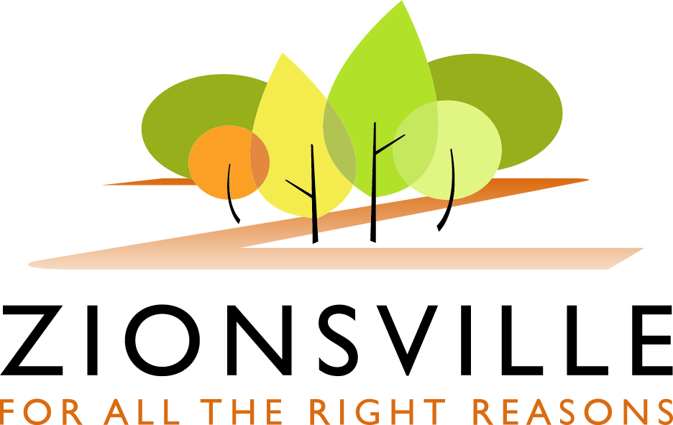

Town of Zionsville

PROCLAMATION

HONORING ZIONSVILLE LITTLE LEAGUE DAY

WHEREAS, Zionsville Little League is committed to being a preeminent educational-athletic organization by encouraging participation, developing character and discipline, promoting teamwork and advocating community pride; and,
WHEREAS, ZLL creates a positive environment in which coaches, parents, fans and players work together to achieve this goal; and
WHEREAS, ZLL has been playing in Lions Park since 1953; and
WHEREAS, ZLL provides boys and girls an opportunity to develop recreational and competitive baseball and softball skills, to instill an enduring love for the games and to build confidence and character through a team-driven setting; and
WHEREAS, ZLL cultivates an environment that welcomes positive involvement and support by parents and family members of all ages; and
WHEREAS, ZLL Spring, Summer and Fall Leagues take place at Lions Park in historic Downtown Zionsville, a safe, family-oriented location; and
WHEREAS, the intimacy of the venue and the spirit of the ZLL families provide an avenue to cultivate lifelong friendships and community relationships.
NOW THEREFORE, celebrating ZLL’s contribution to the community and Opening Night Ceremonies and Games:
The Town of Zionsville, through its Mayor, proclaims April 21, 2017 as
ZIONSVILLE LITTLE LEAGUE DAY
and asks all Citizens to join in this observation.
BE IT FURTHER RESOLVED, that the Town of Zionsville formally honors Zionsville Little League Day and Opening Night Ceremonies and Games on April 21, 2017.
IN TESTIMONY WHEREOF, I have hereunto subscribed my name and caused the seal of the Town of Zionsville to be affixed

TOWN OF ZIONSVILLE, INDIANA
BY ITS MAYOR

_________________________________________
Timothy R. Haak, Mayor

ATTEST:

_________________________________________
Edward J. Mitro, Deputy Mayor

